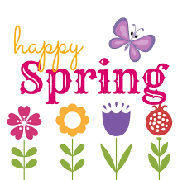
Cypress Newsletter!

May/June 2024

Dear Parents,

Arriving on time (7:45 to 8:00 a.m.), enhances your child’s start to the school day. When your child arrives at the same time as other children, they observe the morning routine. The child naturally joins in, doing what comes next. For example, greeting teachers and each other. Students continue preparing their environment for learning.
During the month of April, your child will be encouraged to continue practicing their social skills, learn to talk to one another in a polite and respectful manner during day and during lunch-time.

Months of May and June

“The child is both a hope and a promise for mankind.”
Maria Montessori

Dear Families,

We will be having a party on Friday, June 7th, 2024 to celebrate Children’s Day. The children may come-in in their pajamas and may bring stuffies (stuff animals). If you would like to donate any food items it would be greatly appreciated.
Thank you for everything you do for your child.

You can help your child succeed in school by making sure they complete their written homework and their IReady computer homework.

First Grade: In Unit 10: Students will be working on Exploring Sound, Light and Heat. Students will be asking questions and creating mental images to build knowledge about sounds. Share ideas about sounds with partners to demonstrate understanding of the topic.
Your child will continue having a Spelling Quiz on Fridays, please make sure they are reading and practicing their words every night. Thank you for continuous support.
First Grade: In Math students will learn Fluency games adding 20. Examples and non-examples of fractions with different shapes. Addition word problems. Odd and even numbers with 2-digit numbers. Numbers in word form from 1 to 100. Subtraction word problems. Creating numerical patterns. Compare word problems. Fluency for the entire week: Fluency addition and subtraction withing 20. Fluency for addition and subtraction within 10. Snake game.
First grade: In science, your child will learn about Forces using Experiments. Introduction to Biomes. Introduction to Ecosystems. Parts of a Stem. Ecosystem / Biomes Project. Parts of a root. Parts of a Leaf. Parts of a Flower. Presentation of the Projects.
First Grade: In social studies, students will be studying US Currency, Wants vs. Needs of humans, Goods and Services and Buying and Saving.
.

Important Dates

Friday, May 10th Mother’s Day Breakfast
Friday May 24th Early Release
Monday, May 27th No School
Friday, May 31st Father’s Day Breakfast

- Please make sure your child has two water bottles every day and a snack.
- Please provide a raincoat for raining days.
- Please prepare your child for all assessments-plenty of sleep and a well-balanced breakfast.
- Dress-down Day on Fridays-$1.00 donation.
- Show-&-Tell on Fridays

Donations

- Lysol wipes
- Snacks
- Boxes of Tissues

Thank you so Much for the recent donations!

Ms. Rachel- If you have any questions or concerns, please feel free to email me at rpulido@sbmontessoricharter.com
crivera@sbmontessoricharter.com

Please Visit the School Website:
South Broward Montessori Charter
(Please visit our site under Classes/Cypress at http://sbmontessoricharter.com/

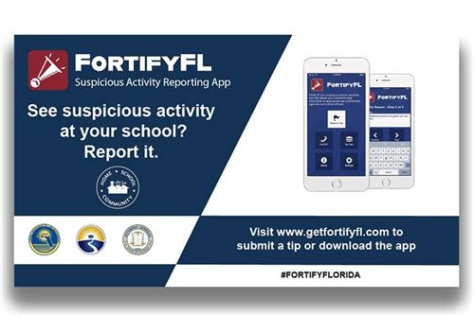

Reminders to Parents

Cypress Newsletter Page 2

